# Answers to Exam Question

Robel Teferi, 610601

__________________________________________________________________________________

## Answers Part – 1

1. False

Rationale: Name is not explicitly defined inside the function. Hello can be printed but name won’t as it is undefined.

1. True

Rationale: Before computing this question, I put into consideration that && has higher precedence than ||(or).

1|| (0 &&3 && 0) => (true|| false&& true&&false)

1|| (0 && 0) => (true|| false&&false)

1|| 0 => (true|| false)

1 => true;

1. False

Rationale: The reason for this is when the position is set to static which means that margin, padding, won’t change. Static positioning displays elements the way they are rendered. They don't comply with any change request ( left, top, right and bottom rules).

1. <p>
2. &lt;p&gt;
3. &lt;a href=&quot;http://www.mum.edu/&quot;&gt; Maharishi University of Management &lt;/a&gt;
4. &lt;/p&gt;
5. </p>
6. <p>

## Answers Part – 2

1. **Question**
2. "use strict";
3. const Account ={
4. accountNumber:"",
5. balance:"0.0",
6. accountType:"",
7. toString: function(speed){
8. return `AccountNumber: ${this.accountNumber}, balance: ${balance} ${this.balance}, AccountType: ${accountType}`}
10. }
12. const savingsAccount = Object.create(Account);
13. savingsAccount.accountNumber = "10001";
14. savingsAccount.balance = 125000.00;
15. savingsAccount.accountType = "Savings";
17. const checkingAccount = Object.create(Account);
18. checkingAccount.accountNumber = "10002";
19. checkingAccount.balance = 75090.50;
20. checkingAccount.accountType = "Checking";
22. savingsAccount.addInterest = function(interestRate){
23. return this.balance + interestRate;
24. }
26. checkingAccount.deductMaintenanceFee = function(maintenanceFeeRate){
27. return this.balance - maintenanceFeeRate;
28. }
30. console.log(savingsAccount.addInterest(1.5/100));
32. console.log(savingsAccount.addInterest(10/100));
34. console.log(savingsAccount.toString());
36. console.log(checkingAccount.toString());

**2. Table**

1. <!DOCTYPE html>
2. <html lang="en">
3. <head>
4. <meta charset="UTF-8">
5. <meta name="viewport" content="width=device-width, initial-scale=1.0">
6. <link rel="stylesheet" href="/css/table.css">
7. <title>Table</title>
9. </style>
10. </head>
11. <body>
12. <table>
13. <thead>
14. <tr>
15. <th>Week</th>
16. <th>Session</th>
17. </tr>
18. </thead>
19. <tbody>
20. <tr>
21. <td rowspan="4">Week 1</td>
22. <td> </td>
23. </tr>
24. <tr><td>a.m.</td></tr>
25. <tr><td>p.m.</td></tr>
26. <tr><td>Eve</td></tr>
27. <tr>
28. <td rowspan="4">Week 2</td>
29. <td> </td>
30. </tr>
31. <tr><td>a.m.</td></tr>
32. <tr><td>p.m.</td></tr>
33. <tr><td>Eve</td></tr>
34. </tbody>
35. </table>
36. </body>
37. </html>

**CSS**

/* main-styles.css */

/* author: Robel Teferi */

/* Exam Date: 2020-05-05 */

table {

    border-collapse: collapse;    }

table, th, td {

    border: 1px solid black;

}

td {

    height: 10px;

}

2.

"use strict";

const Account ={

 accountNumber:"null",

 balance:0.0,

 accountType:"null",

 toString: function(){

  return AccountNumber: ${this.accountNumber}, balance: ${this.balance}, AccountType: ${this.accountType};}

}

const savingsAccount = Object.create(Account);

savingsAccount.accountNumber = "10001";

savingsAccount.balance = 125000.00;

savingsAccount.accountType = "Savings";

const checkingAccount = Object.create(Account);

checkingAccount.accountNumber = "10002";

checkingAccount.balance = 75090.50;

checkingAccount.accountType = "Checking";

savingsAccount.addInterest = function(interestRate){

    return this.balance + (interestRate/100);

}

checkingAccount.deductMaintenanceFee = function(maintenanceFeeRate){

    return this.balance - (maintenanceFeeRate/100);

}

console.log(savingsAccount.addInterest(1.5));

console.log(checkingAccount.deductMaintenanceFee(10));

console.log(savingsAccount.toString());

console.log(checkingAccount.toString());

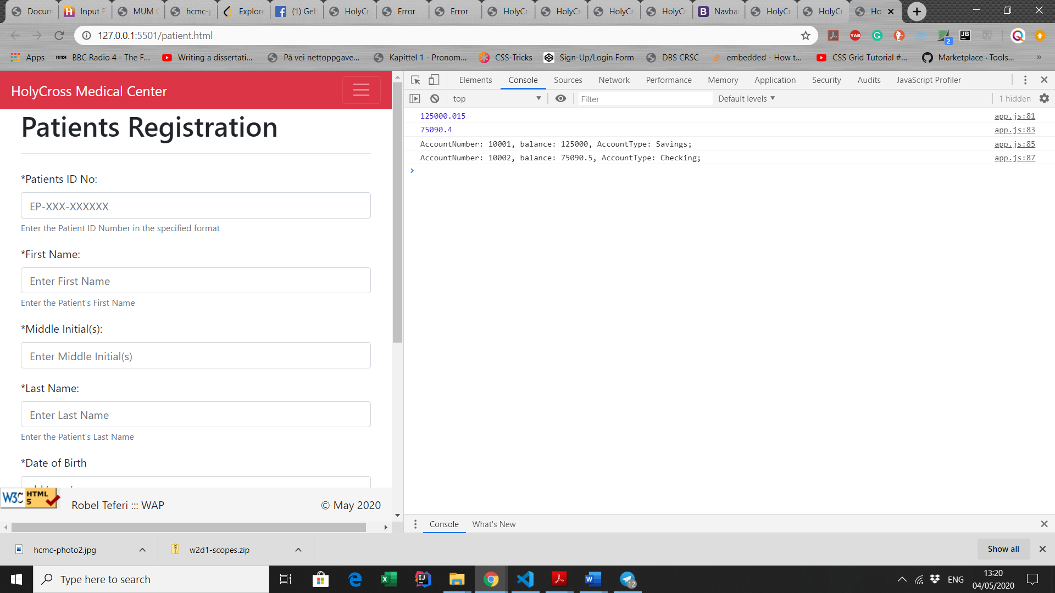

Web Screen Shot

